**Lab 9 Computer Networks**

Name: Tanvi Penumudy

Enroll No: E18CSE187

Batch: EB06

**CONTENTS:**

* Objective (Question)
* Procedure and Documentation (Incl. Snapshots)
* Screenshots

**OBJECTIVE (QUESTION):**

Implement Routing Information Protocol (v1 and v2) protocol on the given network (Provide the IP addressing scheme, screenshot of topology with IP addresses of devices written on them)

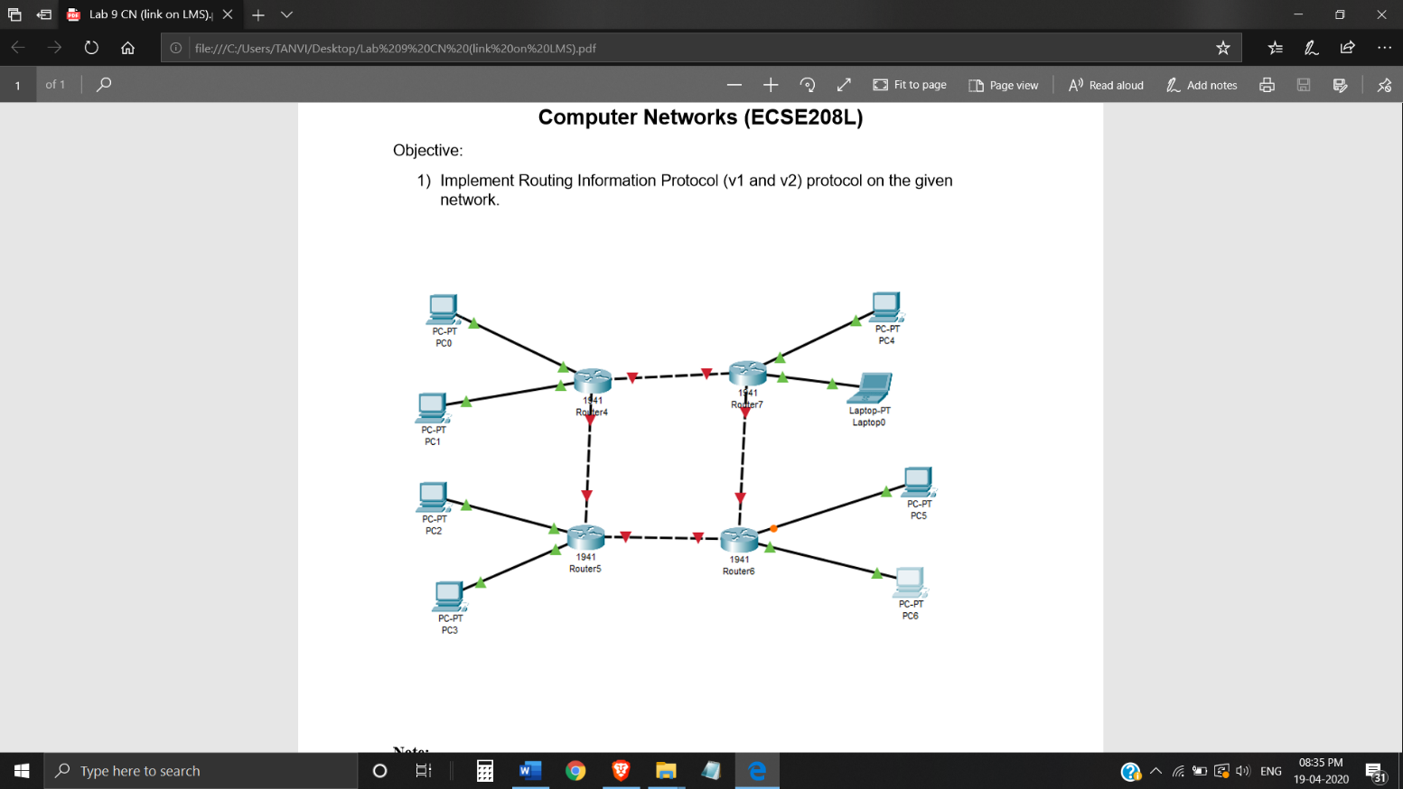

Figure (Given in Question)

**PROCEDURE AND DOCUMENTATION:**

* RIPv1 (Routing Information Protocol Version 1) is a [Distance-Vector Routing protocol](https://www.omnisecu.com/cisco-certified-network-associate-ccna/introduction-to-distance-vector-routing-protocols.php).
* RIPv1 is a Classful routing protocol. Classful routing protocols support only the networks which are not subnetted. Classful routing protocols do not send subnet mask information with their routing updates. In other words, if you have a subnetted network in your RIPv1 routing domain, RIPv1 will announce that network to other as unsubnetted network.
* RIPv1 does not support [VLSM (Variable Length Subnet Masking)](https://www.omnisecu.com/tcpip/variable-length-subnet-masking-vlsm.php).
* **Here we choose classful addressing as RIPv1 (Routing Information Protocol Version 1) doesn’t support Classless Addressing.**
* **In this Network - Class C IP Addressing Scheme is implemented**
* RIPv2 (Routing Information Protocol Version 2) supports [VLSM (Variable Length Subnet Masking)](https://www.omnisecu.com/tcpip/variable-length-subnet-masking-vlsm.php).
* RIPv2 supports maximum [metric](https://www.omnisecu.com/cisco-certified-network-associate-ccna/what-is-routing-metric-value.php) (hop count) value of 15. Any router farther than 15 hops away is considered as unreachable.
* RIPv2 supports triggered updates.
* First set up the network as shown in figure and assign IP addresses to computers, configure routers.
* The following commands (steps as shown below) shall be implemented on CLI (for all the routers):
* Initially, goto the config mode
* (enable,config t) then,
* router rip
* “network IP add” for all the network addresses of router interfaces

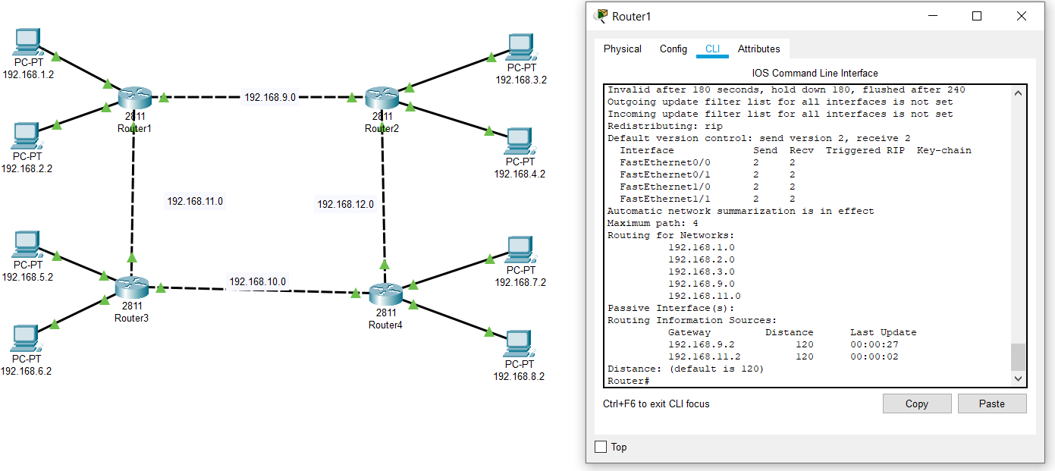

Fig- Screenshot for Configuration

* Set for Router1 :–(Network 192.168.1.1, Network 192.168.2.1, Network 192.168.9.1, Network 192.168.11.1)
* **Similarly:**
* Set for Router2 as :–(Network 192.168.3.1, Network 192.168.4.1, Network 192.168.9.1, Network 192.168.12.1)
* Set for Router3 as :–(Network 192.168.5.1, Network 192.168.6.1, Network 192.168.10.1, Network 192.168.11.1)
* Set for Router4 as :–(Network 192.168.7.1, Network 192.168.8.1, Network 192.168.10.1, Network 192.168.12.1)
* **(See the IP addresses in the below topology for your reference)**

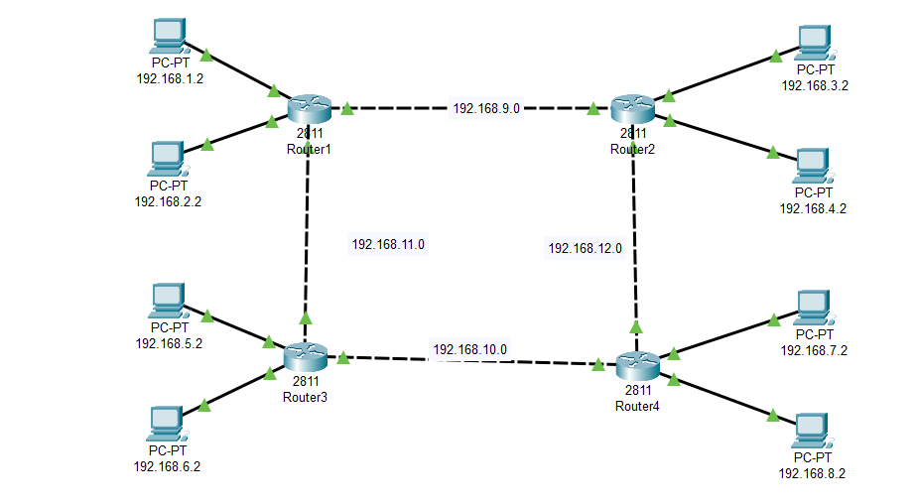

Fig- Screenshot of Topology with IP addresses of devices

* The implementation of **RIP v1 has been done completely.**
* Generally it takes half a minute in order to update the **Routing Table** of all the routers.
* In order to verify, ‘show ip route command’ shall be executed.
* In order to **implement RIP v2** repeat the same procedure as mentioned in the above few steps.
* Along with it, execute the ‘**Version 2 command**’.
* To verify that the RIP v2 protocol has been applied, ‘show ip protocols command’ shall be executed.
* Hereby, the set-up is completed

**SCREENSHOTS:**



